FRAMEWORK FOR FIRST ROUND:

• Create a plan on how to collect social media data concerning customer experiences (AT&T will not provide any data for this competition)

We concentrated on the products and services of AT&T and what customers are saying about these in the social media. Two products came out which customers are discussing a lot about. Those are:

AT&T U-verse (Broadband Internet, IP telephone, IPTV services) – Twitter page AT&T U-verse, Facebook page AT&T U-verse and Yelp page AT&T U-verse.

DIRECTV - Twitter page DIRECTV, Facebook page DIRECTV and Yelp page DIRECTV.

Data for Products and Services - Twitter page AT&T, ATTCares, Facebook page AT&T and Yelp page AT&T.

Steps for collecting tweets from Twitter

1. Call searchTwitter API from the R TwitteR package, passing searchString = ‘@Uverse’ or ‘@DIRECTV’ or ‘@ATT’ or ‘@ATTCares’. We pass the geoCode parameter as the centre latitude/longitude of Dallas + 50 miles. This returns all the tweets in Dallas with some overlapping from adjacent areas.
2. Call the lookupUsers API, for looking up the user information.
3. Call the geoCode API, to get the geolocation of these users in terms of latitude and longitude.
4. Call the revgeoCode API, to get the address and zip code of these users.
5. Prepare a list of all the zip codes in Dallas. Refer Addendum 2.
6. Filter the users from 4, by matching against the list in 5. This segregates users based out of Dallas.

Partial code for this is included in **Twitter.r** file uploaded separately.

Steps for collecting data from Facebook

1. Call the getGroup API from the Rfacebook package, which extracts lists of posts from a public Facebook group.
2. Call the getUsers API to return the list of users by passing the user ids from (1).
3. Get the geolocation of these users in terms of latitude and longitude.
4. Get the address and zipcode of these users by using reverse geolocation.
5. Prepare a list of all the zip codes in Dallas. Refer Addendum 2.
6. Filter the users from 4, by matching against the list in 5. This segregates users based out of Dallas.

Steps for collecting data from Yelp

Similarly, calling Yelp API, we would be retrieving the customer comments from the AT&T, AT&T U-verse and AT&T DIRECTV pages.

Data for **retail stores** based in Dallas: There are 12 AT&T retail stores in Dallas. Exclusive customer care data about these stores can be found in Google reviews about the particular store. Below snapshots show customer comments about a couple of stores:

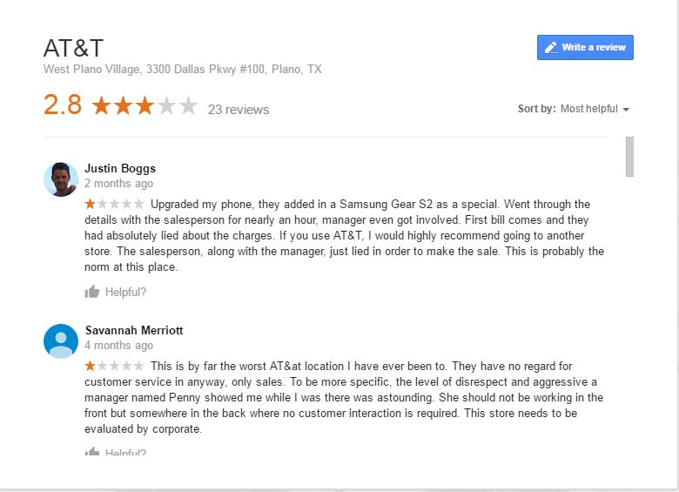

Fig 1. Snapshot of customer comments for AT&T store – West Plano Village, 3300 Dallas Pkwy #100, Plano, TX

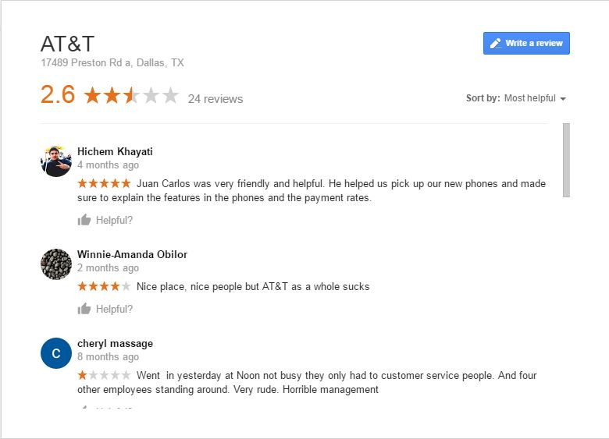

Fig 2. Snapshot of customer comments for AT&T store – 17489, Preston Rd a, Dallas, TX

• Identify key factors that go into positive or negative customer experiences from the data you collected- list the different social media platforms involved in analysis

Analyzing the data from different social media platforms, we have arrived at a number of key factors that go into creating positive or negative customer experiences. The different social media consulted are Twitter, Facebook, Yelp and Google reviews. Those are as follows:

**Negative**

1. Promote Sales – There have been instances when customer care including the manager has lied about plan charges in order to make a sale. Even defective products have been sold.
2. Lackadaisical – There have been instances when customer care has not been proactive in helping customers. Customers may have called DirecTV customer care and asked for U-verse support. Instead of re-directing the call to U-verse, customer care has hung up.
3. Not knowledgeable – Customer care is not knowledgeable enough to answer precisely to customer problems.

**Positive**

1. Knowledgeable and Helpful– Customers have commented positively about knowledgeable and helpful customer care. Such positive instances, though, have been less as compared to negative ones.

For a list of positive and negative sentiment related words gathered from different social media, please refer to Addendum 1.

• Explain retail zone ratings based off of social media data

There are 12 AT&T retail stores in Dallas. We have clubbed the stores based on their locations into East, West, North and South zones.

We have used two approaches to map the user sentiments to the retail zones:

Approach 1 – Sentiments from Google reviews are directly mapped to a store and hence a zone.

Approach 2 – For sentiments obtained from other online platforms like Twitter, Facebook and Yelp, we already have a list of Dallas customers by pin codes from the plan created in Step 1.

We can find the geolocation of the customer from the zip code and map him to the nearest store based on the shortest distance to a store from his location. The assumption is, generally, a customer visits the store nearest to him.

**Rating/Ranking algorithm**

Once, the above segregation is done, we will have x number of positive sentiments and y number of negative sentiments for a store. We decided to give a weight of -2 for each negative sentiment and a weight of 1 for each positive sentiment. The reason is a negative sentiment harms the reputation of a business and hence should be monitored and not nullified by a positive sentiment (If we give -1 to a negative sentiment and +1 to a positive sentiment, the effect of a negative sentiment is nullified by that of a positive sentiment).

We calculate the weighted sum of the positive and the negative sentiments for a store. For example, Store X has 5 negative sentiments and 2 positive sentiments. Hence, its score is (5*-2 + 2*1) or -8.

Store Y may have 2 negative sentiments and 2 positive sentiments. Hence, its score is (2*-2 + 2*1) or -2.

Notice, Store Y inspite of having equal no of positive and negative sentiments has a negative score.

We do a summation of the scores of all stores belonging to a zone and then rank those. The highest score gets the highest rank and vis-à-vis for the lowest score. Let us assume that Store X and Store Y both belong to East zone. They have a cumulative score of (-8+ (-2)) or -10. Similarly, cumulative score of Store A and Store B, assuming both belonging to West zone, may be -8. Hence, West zone ranks higher than East zone.

All of these can be portrayed using appropriate data visualization techniques.

• Present the procedure you would take to drill down to specific retail store customer sentiment and how you would rank the locations based on your findings.

Much of what is discussed in the above point except that instead of doing a cumulative score of the stores to determine a rank for a zone, we rank the individual store using the same logic.

Again, we will portray these using data visualization techniques.

**Value-add** – Some of the positive or negative comments have the name of the customer care person. Through our analysis, we can report the representatives who have received kudos and the ones against whom customers have complaints.

AT&T can give added incentives for the former and a reprimandation for the latter.

• Extra Deliverable: Dive deeper into the data and utilize data analytic techniques to go along with your procedure. This is not required but welcomed if you have time.

We are uploading the **Twitter.r** file. This has the code to extract data from Twitter and get users by their geolocation. This code will be expanded in future.

We can also show exclusively what customer sentiments are for AT&T U-verse and AT&T DIRECTV products. We have data about these products extracted from related pages in Twitter, Facebook and Yelp. A sentiment analysis can be done on the comments. The number of positive and negative sentiments for a product can be plotted using appropriate **data visualization** techniques.

Addendum 1

List of positive and negative sentiments gathered from social media

Some of the negative sentiment words, from the tweets and reviews.

|  |  |  |  |  |
| --- | --- | --- | --- | --- |
| poor | worst | nothing | terrible | slow |
| sucks | flaky | scrap | pissed | shameful |
| unacceptable | disrespectful | incompetent | rude | horrible |
| dismissing | struggling |  |  |  |

Some of the positive sentiment words, from the tweets and reviews.

|  |  |  |  |  |
| --- | --- | --- | --- | --- |
| thankyou | awesome | missATT | switchtoatt | great |
| great | friendly | helpful | satisfied |  |

Bag of words obtained from tweets in Uverse_Dallas.csv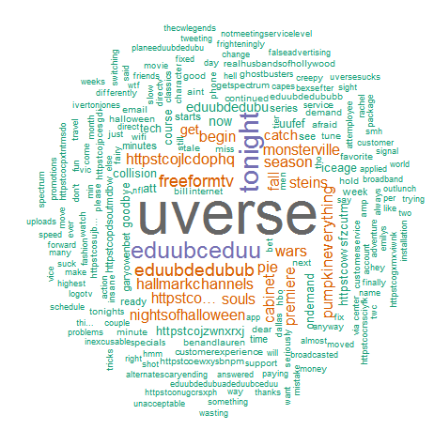

Addendum 2

List of Dallas zip codes:

* [75019](http://www.zillow.com/browse/homes/tx/dallas-county/75019/)
* [75039](http://www.zillow.com/browse/homes/tx/dallas-county/75039/)
* [75038](http://www.zillow.com/browse/homes/tx/dallas-county/75038/)
* [75041](http://www.zillow.com/browse/homes/tx/dallas-county/75041/)
* [75040](http://www.zillow.com/browse/homes/tx/dallas-county/75040/)
* [75043](http://www.zillow.com/browse/homes/tx/dallas-county/75043/)
* [75042](http://www.zillow.com/browse/homes/tx/dallas-county/75042/)
* [75044](http://www.zillow.com/browse/homes/tx/dallas-county/75044/)
* [75049](http://www.zillow.com/browse/homes/tx/dallas-county/75049/)
* [75048](http://www.zillow.com/browse/homes/tx/dallas-county/75048/)
* [75051](http://www.zillow.com/browse/homes/tx/dallas-county/75051/)
* [75050](http://www.zillow.com/browse/homes/tx/dallas-county/75050/)
* [75052](http://www.zillow.com/browse/homes/tx/dallas-county/75052/)
* [75054](http://www.zillow.com/browse/homes/tx/dallas-county/75054/)
* [75061](http://www.zillow.com/browse/homes/tx/dallas-county/75061/)
* [75060](http://www.zillow.com/browse/homes/tx/dallas-county/75060/)
* [75063](http://www.zillow.com/browse/homes/tx/dallas-county/75063/)
* [75062](http://www.zillow.com/browse/homes/tx/dallas-county/75062/)
* [75080](http://www.zillow.com/browse/homes/tx/dallas-county/75080/)
* [75082](http://www.zillow.com/browse/homes/tx/dallas-county/75082/)
* [75081](http://www.zillow.com/browse/homes/tx/dallas-county/75081/)
* [75089](http://www.zillow.com/browse/homes/tx/dallas-county/75089/)
* [75088](http://www.zillow.com/browse/homes/tx/dallas-county/75088/)
* [75099](http://www.zillow.com/browse/homes/tx/dallas-county/75099/)
* [75104](http://www.zillow.com/browse/homes/tx/dallas-county/75104/)
* [75106](http://www.zillow.com/browse/homes/tx/dallas-county/75106/)
* [75115](http://www.zillow.com/browse/homes/tx/dallas-county/75115/)
* [75116](http://www.zillow.com/browse/homes/tx/dallas-county/75116/)
* [75125](http://www.zillow.com/browse/homes/tx/dallas-county/75125/)
* [75134](http://www.zillow.com/browse/homes/tx/dallas-county/75134/)
* [75137](http://www.zillow.com/browse/homes/tx/dallas-county/75137/)
* [75141](http://www.zillow.com/browse/homes/tx/dallas-county/75141/)
* [75146](http://www.zillow.com/browse/homes/tx/dallas-county/75146/)
* [75150](http://www.zillow.com/browse/homes/tx/dallas-county/75150/)
* [75149](http://www.zillow.com/browse/homes/tx/dallas-county/75149/)
* [75154](http://www.zillow.com/browse/homes/tx/dallas-county/75154/)
* [75159](http://www.zillow.com/browse/homes/tx/dallas-county/75159/)
* [75172](http://www.zillow.com/browse/homes/tx/dallas-county/75172/)
* [75181](http://www.zillow.com/browse/homes/tx/dallas-county/75181/)
* [75180](http://www.zillow.com/browse/homes/tx/dallas-county/75180/)
* [75182](http://www.zillow.com/browse/homes/tx/dallas-county/75182/)
* [75202](http://www.zillow.com/browse/homes/tx/dallas-county/75202/)
* [75201](http://www.zillow.com/browse/homes/tx/dallas-county/75201/)
* [75204](http://www.zillow.com/browse/homes/tx/dallas-county/75204/)
* [75203](http://www.zillow.com/browse/homes/tx/dallas-county/75203/)
* [75206](http://www.zillow.com/browse/homes/tx/dallas-county/75206/)
* [75205](http://www.zillow.com/browse/homes/tx/dallas-county/75205/)
* [75208](http://www.zillow.com/browse/homes/tx/dallas-county/75208/)
* [75207](http://www.zillow.com/browse/homes/tx/dallas-county/75207/)
* [75210](http://www.zillow.com/browse/homes/tx/dallas-county/75210/)
* [75209](http://www.zillow.com/browse/homes/tx/dallas-county/75209/)
* [75212](http://www.zillow.com/browse/homes/tx/dallas-county/75212/)
* [75211](http://www.zillow.com/browse/homes/tx/dallas-county/75211/)
* [75215](http://www.zillow.com/browse/homes/tx/dallas-county/75215/)
* [75214](http://www.zillow.com/browse/homes/tx/dallas-county/75214/)
* [75217](http://www.zillow.com/browse/homes/tx/dallas-county/75217/)
* [75216](http://www.zillow.com/browse/homes/tx/dallas-county/75216/)
* [75219](http://www.zillow.com/browse/homes/tx/dallas-county/75219/)
* [75218](http://www.zillow.com/browse/homes/tx/dallas-county/75218/)
* [75220](http://www.zillow.com/browse/homes/tx/dallas-county/75220/)
* [75223](http://www.zillow.com/browse/homes/tx/dallas-county/75223/)
* [75222](http://www.zillow.com/browse/homes/tx/dallas-county/75222/)
* [75225](http://www.zillow.com/browse/homes/tx/dallas-county/75225/)
* [75224](http://www.zillow.com/browse/homes/tx/dallas-county/75224/)
* [75227](http://www.zillow.com/browse/homes/tx/dallas-county/75227/)
* [75226](http://www.zillow.com/browse/homes/tx/dallas-county/75226/)
* [75229](http://www.zillow.com/browse/homes/tx/dallas-county/75229/)
* [75228](http://www.zillow.com/browse/homes/tx/dallas-county/75228/)
* [75231](http://www.zillow.com/browse/homes/tx/dallas-county/75231/)
* [75230](http://www.zillow.com/browse/homes/tx/dallas-county/75230/)
* [75233](http://www.zillow.com/browse/homes/tx/dallas-county/75233/)
* [75232](http://www.zillow.com/browse/homes/tx/dallas-county/75232/)
* [75235](http://www.zillow.com/browse/homes/tx/dallas-county/75235/)
* [75234](http://www.zillow.com/browse/homes/tx/dallas-county/75234/)
* [75237](http://www.zillow.com/browse/homes/tx/dallas-county/75237/)
* [75236](http://www.zillow.com/browse/homes/tx/dallas-county/75236/)
* [75238](http://www.zillow.com/browse/homes/tx/dallas-county/75238/)
* [75241](http://www.zillow.com/browse/homes/tx/dallas-county/75241/)
* [75240](http://www.zillow.com/browse/homes/tx/dallas-county/75240/)
* [75243](http://www.zillow.com/browse/homes/tx/dallas-county/75243/)
* [75242](http://www.zillow.com/browse/homes/tx/dallas-county/75242/)
* [75244](http://www.zillow.com/browse/homes/tx/dallas-county/75244/)
* [75247](http://www.zillow.com/browse/homes/tx/dallas-county/75247/)
* [75246](http://www.zillow.com/browse/homes/tx/dallas-county/75246/)
* [75249](http://www.zillow.com/browse/homes/tx/dallas-county/75249/)
* [75248](http://www.zillow.com/browse/homes/tx/dallas-county/75248/)
* [75251](http://www.zillow.com/browse/homes/tx/dallas-county/75251/)
* [75250](http://www.zillow.com/browse/homes/tx/dallas-county/75250/)
* [75253](http://www.zillow.com/browse/homes/tx/dallas-county/75253/)
* [75254](http://www.zillow.com/browse/homes/tx/dallas-county/75254/)
* [75260](http://www.zillow.com/browse/homes/tx/dallas-county/75260/)
* [75275](http://www.zillow.com/browse/homes/tx/dallas-county/75275/)
* [75283](http://www.zillow.com/browse/homes/tx/dallas-county/75283/)
* [75284](http://www.zillow.com/browse/homes/tx/dallas-county/75284/)
* [75326](http://www.zillow.com/browse/homes/tx/dallas-county/75326/)
* [75359](http://www.zillow.com/browse/homes/tx/dallas-county/75359/)
* [75381](http://www.zillow.com/browse/homes/tx/dallas-county/75381/)
* [75001](http://www.zillow.com/browse/homes/tx/dallas-county/75001/)
* [75390](http://www.zillow.com/browse/homes/tx/dallas-county/75390/)
* [75006](http://www.zillow.com/browse/homes/tx/dallas-county/75006/)
* [75007](http://www.zillow.com/browse/homes/tx/dallas-county/75007/)
* [75397](http://www.zillow.com/browse/homes/tx/dallas-county/75397/)
* [75015](http://www.zillow.com/browse/homes/tx/dallas-county/75015/)

Addendum 4

What else is being uploaded:

1. Non-disclosure agreement signed by each participant(Shouvik Pal, Sanket Panaskar, Anees Mohammed) – Total 3
2. Flow Diagram – AT&T.pptx
3. Supporting code – Twitter.r
4. Twitter extract for AT&T Dallas - ATT_Dallas.csv
5. Twitter extract for AT&T U-verse Dallas - Uverse_Dallas.csv
6. Twitter extract for AT&T DIRECTV Dallas - DIRECTV_Dallas.csv